List:

List can have different datatypes.

Namely,same dt,mixed dt,nested list

Eg: [[1,2,3,4,5,6],90,[1,2,3]]

Accessing methods:

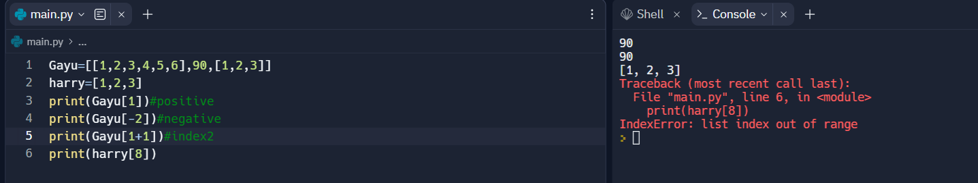

Operators:

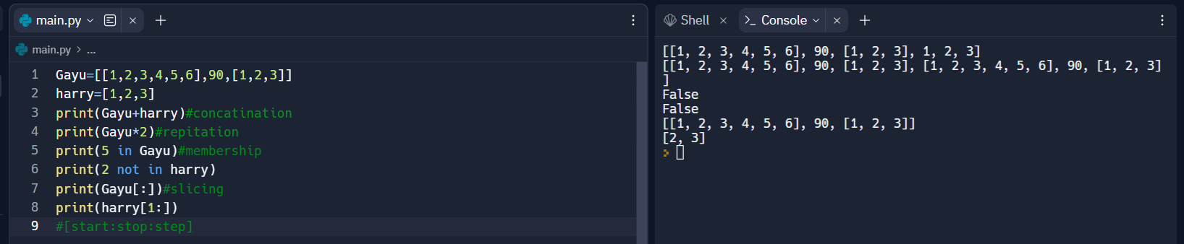

Traversing:

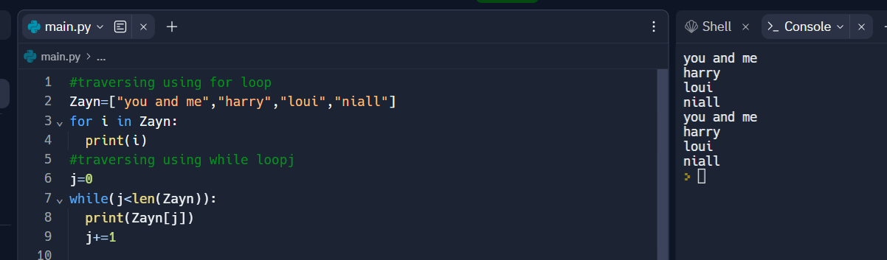

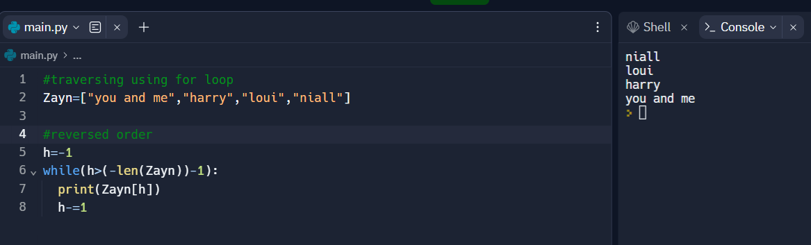

Inbuit functions:

List manipulation:

